Title Page

Table of Contents
Risk Analysis 3
Introduction 3
Risk Identiﬁcation 3
Risk Assessment 4
Risk Mitigation 6
Conclusion 7
Stakeholder Management Plan 8
Introduction 8
Stakeholder Identification 8
Stakeholder Analysis 9
Engagement Strategies 11
Objectives and Measures for Stakeholders 12
Conclusion 13
References 13

Risk Analysis

Introduction
The EHR system at Riverbend Hospital enables several ways to improve not only the delivery of patient care but also operational efficiency. In any case, there is a need to identify, assess, and mitigate many risks in a structured manner for successful project execution. This is brought out by using 5 x 5 Risk Assessment Matrix methods by Chapman & Ward (2019) and Hillson & Simon (2020) that help in obtaining critical assessments of the risks that could be there in association with the EHR Implementation Project.

Risk Identiﬁcation
Some of the risks to the EHR project at Riverbend Hospital that would be detected early to the success of the project:
- Data Migration Errors: These are Possible ways of losing data or inaccuracies in the migration from paper-based traditional records to electronic systems. This will be determined by broad reviews of the current data including accuracy checks and tests of preparedness for migration (Chapman & Ward, 2019)
- Staff resistance: The healthcare providers and administrative staff are also likely to resist the implementation of the new EHR system. This will be identified with stakeholder analysis, which includes surveys and interviews, to assess staff readiness and identify areas that could manifest resistance (Olander, 2022).
- System Integration Issues: Problems may be experienced during the integration of the new EHR system with other hospital systems, including billing and scheduling systems. These risks will be identified by reviewing the current IT infrastructure and conducting compatibility assessments with existing systems (Wrike, 2024).
- Budget Overspending: Large-scale IT projects have risks of overspending the budget. This will be identified through good financial planning and analysis of records for similar projects, which can ease early detection of potential courses of overspending (Hillson & Simon, 2020).
- Data Security Breaches: Protection of patient information against unauthorized access is important. This risk shall be assessed by carrying out whole cybersecurity testing to analyze possible loopholes in the EHR system (Hillson & Simon, 2020).
- Technical Failures: There is a risk of system downtime or technological failure that might influence the operations of the EHR system. This risk shall be measured by the use of stress tests and continuous monitoring of the particular system's performance under varying conditions (Chapman & Ward, 2019).
- Regulatory Compliance issues: The EHR system should have the ability to ensure compliance with the regulations concerning healthcare. This risk will be identified by keeping updated about the regulatory requirements and executing regular audits concerning compliance (PMI 2021).
- Inefficiency of Training: This will lead to mistakes in the use of the EHR system. A risk like this can be identified by collecting feedback from training sessions and assessing users' behavior in finding knowledge gaps (Wrike, 2024).

Risk Assessment
The 5x5 risk matrix (Figure 1) is considered one of the most helpful methods for the assessment of project risks, based on the probability of occurrence and potential impact. According to this matrix, the risk can be grouped into five levels of probability from "Rare" to "Almost Certain" and into five levels of impact from "Insignificant" to "Severe". The plotting of risks on this matrix will calculate their severity, which supports prioritization and further management.
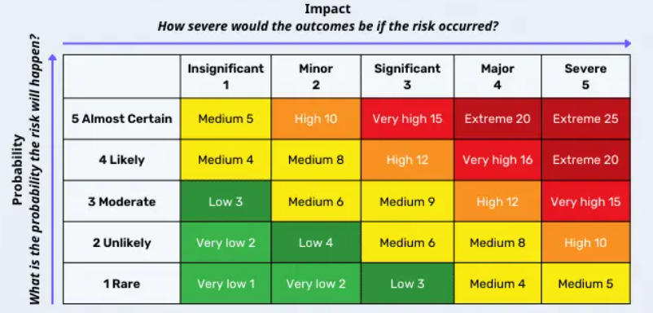
Figure 1: Risk Assessment Matrix
Source: https://safetyculture.com/topics/risk-assessment/5x5-risk-matrix/

- Data Migration Errors: The impact of these errors is high with a moderate probability that delays to treatments or incorrect treatments for patients can occur from such errors. The complexity associated with migrating from paper to electronic records increases the likelihood of such problems. Addressing data migration challenges will be critical in ensuring that patient information remains complete and reliable throughout the implementation process (Chapman and Ward, 2019; Hillson and Simon, 2020).
- Staff Resistance: The EHR project is more likely to encounter staff resistance, which reflects its high impact. Because of changes in workflow and learning to utilize new technology, some level of resistance to the change is very likely to occur. This may cause severe disruption during the implementation phase and impact overall efficiency in using the EHR system. In this regard, it is very important to plan for and address staff concerns well in advance to ensure that the transition is smoother (Wrike, 2024; Project Management, 2023).
- System Integration Issues: These risks have a moderate probability but are significantly consequential. Integrating an EHR system with the various infrastructures already present in the hospital is an extremely complex task beset with delays and operational inefficiencies. Therefore, this risk category means that though integration issues are likely to be fair to mid-scale, their potential to disrupt the project's timeline and operations makes them a critical concern (Kerzner 2017; Invensis Learning, 2023).
- Budget Overruns: The project may be at a high risk from budget overruns. It is likely to happen, with an impact of great magnitude. In large IT projects, such as the one involving EHR implementation, occurrences of unforeseen expenses are common. Such unforeseen expenses result in strain on the resources and a compromise either in the project scope or quality. The reason to control this risk would be to keep the project within budget and have all the planned features and functionalities delivered (SafetyCulture, 2023; Chapman & Ward, 2019).
- Data Security Breaches: They are highly unlikely; nevertheless, the impact will be severe. Though their likelihood is minimized through solid security measures, if they were to happen, patient confidentiality might get breached and may lead to serious legal and reputational consequences. The risk thus demands strict data security practices to be maintained during the EHR project (Hillson & Simon, 2020; PMI, 2021).
- Technical Failures: These would present a reasonable probability and a significant adverse impact on the EHR project. Technical failure is expected during the initial phase of the implementation and it may make the system unavailable and lead to disruption in the operations of the hospitals. It can be handled appropriately by ensuring the reliability of technical systems and providing timely support (BigPicture, 2023; Kerzner, 2017).
- Regulatory Compliance: There is a low likelihood of the occurrence of a risk event but in case it occurs, the impact would be major. The potential fines issued, legal actions, and delays of projects make it critical to satisfy regulatory bodies' requirements. The process requires ongoing scrutiny for compliance issues that might determine the fate of a project during its entire life cycle. (Olander, 2022; Cleland, 1986)​
- Inefficiency of Training: One such high-impact risk for the EHR project may be ineffective training. If the training programs are not prepared appropriately to meet the needs of the users, inappropriate use of the EHR system may lead to reduced operational efficiency. Effective designs in training are crucial for the staff to use the new system effectively and efficiently.

Risk Mitigation
After assessing the risks based on their likelihood and impact, it is essential to devise practical measures to mitigate them.
- Data Migration Errors: The project will use a phased data migration approach supported by automated tools and parallel testing to ensure data accuracy. In addition, keeping backup copies of all records will serve as a fallback position to prevent any form of data loss in this regard (Project Manager, 2023).
- Staff Resistance: To overcome the resistance, early and continuous engagement will be carried out for both clinical and administrative staff so that the implementation process will take their suggestions and provide comprehensive training programs according to the specific roles of each one of them. Wherever resistance arises, early adopter incentives along with adaptive feedback mechanisms would be employed to encourage the participation of all stakeholders (Olander, 2022).
- System integration Issues: These will be mitigated through detailed compatibility assessments, as well as collaboration with experienced IT vendors, to ensure that the new EHR system works well with current hospital systems, such as billing and scheduling. Management is advised to allocate more time for testing and troubleshooting as a contingency measure (Chapman & Ward, 2019).
- Budget Overruns: To mitigate the risk of budget overruns, a comprehensive budget plan will be formulated that incorporates contingency funds. Ongoing oversight of expenditures, alongside the implementation of cost-control strategies, will contribute to maintaining the project's alignment with financial expectations. Should budgetary issues emerge, it will be possible to redistribute resources from areas of lesser priority or pursue supplementary funding (Invensis Learning, 2023).
- Data Security Breaches: They can be mitigated through robust cybersecurity protocols encryption, access controls, and regular security audits data breaches can be mitigated. An incident response plan will be established to quickly address and mitigate any breaches (Hillson & Simon, 2020).
- Technical Failures: The mitigation approach to these risks involves plans to ensure the IT infrastructure is reliable through standby systems and regular checks. A technical support team will be on call to ensure that the problem can be immediately detected and fixed (Project Management, 2023).
- Regulatory Compliance Risk: These risks can be reduced by a provider if changes in healthcare regulations are known and their EHR system meets all existing standards (PMI, 2021). Compliance audits, for this reason, should routinely be performed to ascertain any discrepancies and address one's practices toward correction to remain compliant with these regulations.
- Inefficiency in Training: This requires the design and implementation of comprehensive training programs, considering diverse user roles, alongside continuing support (Project Manager, 2023). To mitigate this risk, new courses and other training classes should be provided so that any deficiency in the knowledge of users is filled and the system is put into use effectively.

Conclusion
The EHR Implementation Project at Riverbend Hospital presents huge opportunities for the betterment of patient care and operational efficiency. Besides this, there is an imperative requirement to identify and mitigate potential risks to ensure that the project successfully meets its strategic objectives by minimizing adverse impacts. Using structured risk assessment techniques coupled with strong mitigation strategies will enable Riverbend Hospital to overcome any complexities of the EHR implementation process and achieve its strategic objectives by minimizing adverse impacts.

Stakeholder Management Plan

Introduction
For the Riverbend Hospital EHR Implementation Project to succeed, particularly in stakeholder management, the identification and subsequent analysis will be informed by the proposed identification and analysis frameworks respectively from Freeman, 1984; Mitchell et al., 1997; Bourne & Walker, 2005. This helps to ensure effective, holistic engagement strategies within the framework of the stated goals for smooth implementation and a cooperative environment throughout the project lifecycle.

Stakeholder Identification
Identification of stakeholders in the EHR Implementation Project for Riverbend Hospital can be classified using Freeman's (1984) stakeholder framework and Mitchell et al.'s (1997) salience model. The models help in understanding the interests of stakeholders and categorizing them based on their attributes.
- Executive Team: This is the highest level of hospital management, which undertakes strategic decisions and provides an overview of the whole project. They also play an important role in budget approval and project objective settings.
- IT Department: This constitutes all the technical personnel involved in the implementation, integration, and maintenance of the EHR system. They ensure that the technical aspect of the EHR system aligns with the infrastructure and security standards of the hospital.
- Healthcare Providers (Doctors, Nurses): Those who will be in direct contact with the EHR system in the course of daily clinical duties. Their participation is very instrumental in ensuring the system supports clinical workflows and supports patient care.
- Administrative Staff: The administration handles the records of patients as well as certain aspects of operational duties. Because they have to put in data and maintain information in the EHR system, their input is salient to ensure that the system works efficiently and effectively in all administrative applications.
- Patients: These are the end-users of the EHR system, where their treatment can be changed or at least optimized because this system affects how easy or difficult it is to get the medical records. Even though patients may not directly participate in the project, their experiences provide vital information on the success or failure of such a system.
- Vendors/Suppliers: This would include those who would be providing the EHR system together with associated services. Examples include software developers, consultants, and support staff charged with delivering the EHR solution and ensuring its ongoing operability.

- Regulatory Bodies: These ensure that regulated standards and requirements in the health sector are well followed. They make sure the EHR system meets all legal and ethical obligations for the protection of data protection and privacy.
The identification of these stakeholders facilitates an understanding of their respective roles in planning for effective engagement through the EHR implementation project (Freeman, 1984; Mitchell et al., 1997).

Stakeholder Analysis
Stakeholder analysis will be important in ascertaining the different interests and influence that various groups have regarding the EHR Implementation Project at Riverbend Hospital. This could be enriched through the use of Mendelow's Matrix to evaluate several stakeholders in terms of their power and level of interest.
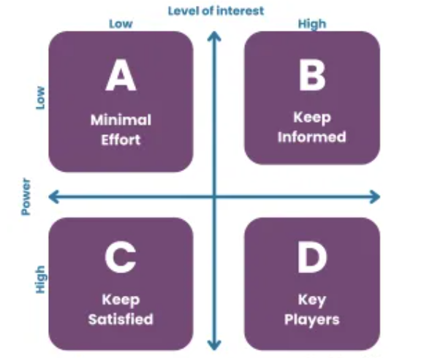
Figure 2: Stakeholder Analysis Matrix - Interest & Influence
Source: Mendelow (1981)
- Executive Team: Their interest in the EHR Implementation Project is very high because this project directly impacts strategic alignment, project success, and return on investment. This team ensures that the projects meet organizational goals and can maintain efficiency and effectiveness to deliver expected results (Freeman, 1984). Their power to influence can also be rated high because they have control over project funding, strategic direction, and overall approval (Mendelow, 1981). The decisions of this group can hence have a great effect on the progress or success of this project.
- IT Department: The interest in the project from this section is high, as the discussion is mainly about technical feasibility, integration of systems, and the security of data (Hillson & Simon, 2020). This encompasses not only the implementation of the EHR system but also its integration with the prevailing infrastructural set-up. The power of influence from this stakeholder would also be high since, in their absence, their technical support might render the system incapable of attaining a critical operational level, apart from their continuous maintenance performance (Chapman & Ward, 2019).
- Healthcare providers: They namely doctors and nurses, are extremely interested in the EHR system, mainly related to the completeness of clinical workflows, usability, and quality of patient care. They need the system to be user-friendly and to successfully support their clinical activities. Their power is medium; while their acceptance of the system is crucial for its success, they do not have the same level of control over the project as the Executive Team or IT Department does (Brugha & Varvasovszky, 2000).
- Administrative Staff: The level of interest by administrative staff is medium since the EHR system will be influencing their efficiency concerning administrative processes and the usability of the system in managing data (Kerzner, 2017). Therefore, they are powerful stakeholders regarding day-to-day operations and data input, although their level of influence is medium. In the context of the EHR system operational implementation, they are needed; however, their direct influence on the project decisions is lower than that of the Executive Team and IT Department (Olander, 2022).
- Patients: They have a moderate level of interest in the EHR system. They are most concerned with record privacy, quality of care provided, and accessibility of information with ease (Hillson & Simon, 2020). They do have a low level of influence on the project. Although the advantages of the system will have direct relevance to their healthcare, their participation in decision-making is extremely limited.
- Vendors/Suppliers: Their interest is considered medium as they are interested in the fulfillment of the contract and system performance and follow-on support. In the context of the EHR system, the influence of these players is considered high due to their role in the provision and maintenance of the system. As already noted they are fundamental in ensuring the system is proving effective and solving any problems that may arise.
- Regulatory Bodies: They express interest at a very low level, mainly to ensure that the health regulations and standards of protection for data given are followed. Their powers are high because failure to comply with any given regulation may bring the project to a standstill or even major legal issues. The influence would ensure the project meets the expected standards (Mitchell et al., 1997).

Engagement Strategies
Each stakeholder group needs to have a very specific engagement strategy since their interests and levels of influence differ. The strategies proposed below will help develop effective communication and collaboration:
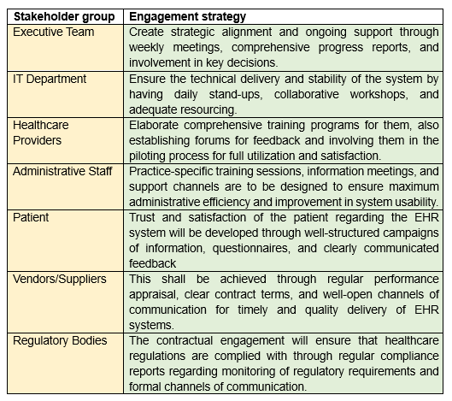

Objectives and Measures for Stakeholders
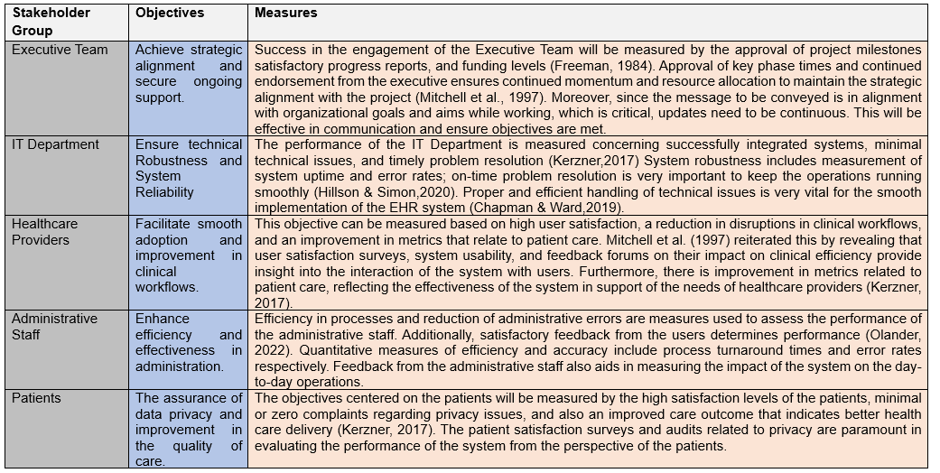
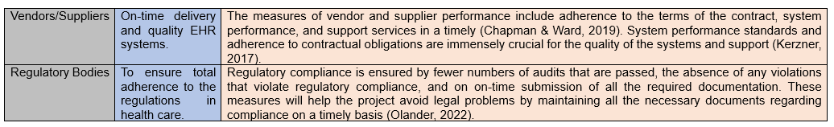

Conclusion
The EHR Implementation Project Stakeholder Management Plan at Riverbend Hospital emphasizes identification, analysis, and effective stakeholder engagement-usually a guarantee for project success. The project team should be able to establish solid relationships, reduce conflicts, and align the interests of stakeholders with project objectives by the use of strong frameworks and customized strategies for engagement. The adaptive strategies guarantee that continuous communication and periodic feedback will bring all stakeholders on board throughout the project life cycle for continuous information, involvement, and support that result in better outcomes.

References
- BigPicture. (2023). Project risk assessment examples. Retrieved from https://bigpicture.one/blog/project-risk-assessment-examples/
- Bourne, L., & Walker, D. H. (2005). Visualizing and mapping stakeholder influence. Management Decision, 43(5), 649-660.
- Brugha, R., & Varvasovszky, Z. (2000). Stakeholder analysis: a review. Health Policy and Planning, 15(3), 239-246.
- Chapman, C., & Ward, S. (2019). Project risk management: Processes, techniques, and insights. Wiley.
- Cleland, D. I. (1986). Strategic management of teams. Wiley.
- Freeman, R. E. (1984). Strategic management: A stakeholder approach. Boston: Pitman.
- Hillson, D., & Simon, P. (2020). Practical project risk management: The ATOM methodology (3rd ed.). CRC Press.
- Invensis Learning. (2023). Risk mitigation strategies in project management. Retrieved from https://www.invensislearning.com/blog/risk-mitigation-strategies-in-project-management/
- Kerzner, H. (2017). Project management: A systems approach to planning, scheduling, and controlling. Wiley.
- Mendelow, A. L. (1981). Environmental scanning—The impact of the stakeholder concept. In Proceedings of the Second International Conference on Information Systems (pp. 407-418).
- Mitchell, R. K., Agle, B. R., & Wood, D. J. (1997). Toward a theory of stakeholder identification and salience: Defining the principle of who and what really counts. Academy of Management Review, 22(4), 853-886.
- Olander, S. (2022). Stakeholder management: A practical guide. Routledge.
- PMI. (2021). A guide to the project management body of knowledge (PMBOK guide) (7th ed.). Project Management Institute.
- Project Manager. (2023). How to mitigate risk in a project. Retrieved from https://www.projectmanager.com/blog/mitigate-risk-project
- Project Management (2023). Diagramming techniques to identify risks. Retrieved from https://project-management.com/diagramming-techniques-to-identify-risks/
- SafetyCulture. (2023). How to use a 5x5 risk assessment matrix. Retrieved from https://safetyculture.com/topics/risk-assessment/5x5-risk-matrix/
- Wrike. (2024). What is risk identification in project management? Retrieved from https://www.wrike.com/blog/what-is-risk-identification-project-management/

